**The UNs Agenda is for 80% of Australia to be given over by 2030 (print version)**

**“You'll Own Nothing and You'll Be Happy”**

[Josephine Cashman](https://substack.com/@josephinecashman) https://josephinecashman.substack.com/p/the-uns-agenda-is-for-80-of-australia?utm\_source=substack&utm\_medium=email

5 Oct 2022

Bestselling author Richard Poe's decades-long research confirmed Josephine Cashman discovered a plot to deceive and manipulate Indigenous people into supporting UN land grabs to break up nations.

This not only applies to Australia but the US and Canada as well. [i]

The Uluru Statement is a momentous fraud, an abomination against all Australians.

The Prime Minister has made the Uluru Statement a priority.

The agenda is to divide the country.

The UN logo was projected onto Ayers Rock (Uluru) ‘claiming’ an Australian icon. [ii]

[[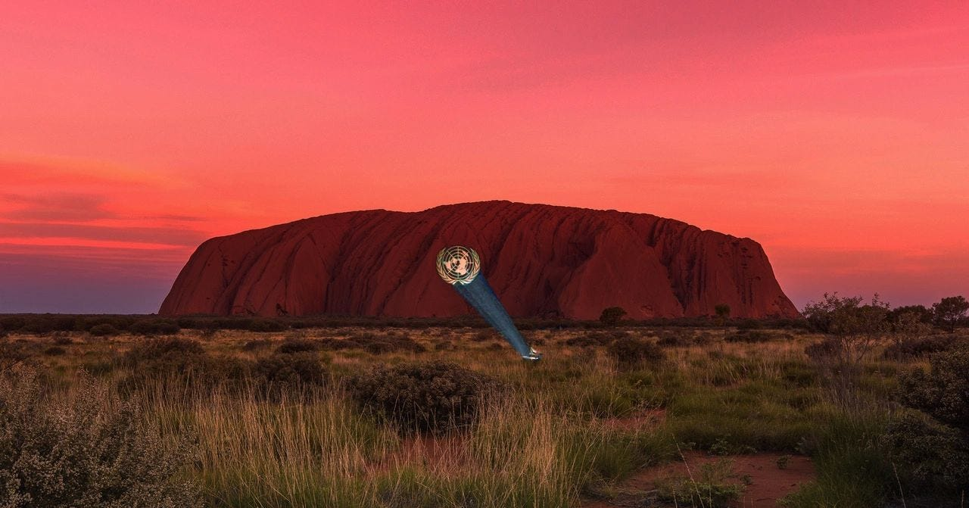](https://substackcdn.com/image/fetch/f_auto,q_auto:good,fl_progressive:steep/https%3A%2F%2Fbucketeer-e05bbc84-baa3-437e-9518-adb32be77984.s3.amazonaws.com%2Fpublic%2Fimages%2Fc6f18754-23e6-4db6-8d56-f439baec5d6a_1280x671.jpeg)](https://substackcdn.com/image/fetch/f_auto,q_auto:good,fl_progressive:steep/https%3A%2F%2Fbucketeer-e05bbc84-baa3-437e-9518-adb32be77984.s3.amazonaws.com%2Fpublic%2Fimages%2Fc6f18754-23e6-4db6-8d56-f439baec5d6a_1280x671.jpeg" \t "_blank)

The Uluru Statement is not the agenda of people living in aboriginal communities. [iii]

They have no say and bear the backlash of decades of government failure. [iv]

International business, government, institutions and the controlled media are working with UN actors to push a race agenda as a cover for Australians to surrender their country. [v]

UN[vi] actors[vii] deceived Australians with honourable intentions for their fellow countrymen in 1967 with 90.77% of voters vote in favour, [viii]

They are now using the same tactics to try to change the constitution again.

The change to the constitution in 1967 allowed failed bureaucrats[ix]and fake aboriginals[x]to create an industry to siphon money[xi], deliberately creating dysfunction by demolishing whatever was working.

Lionel Murphy, disgraced High Court judge[xii]supported UN treaties having influence over Australian law.[xiii]

Justice Murphy also introduced the Terra Nullius fabricated language [xiv] in 1979[xv].

Bruce Pascoe is using this fiction to argue that the land was stolen.[xvi]

Keating used the opportunity of the Torres Strait Island Mabo decision to cover all of Australia with the Native Title Act [xvii] drafted at the UN. [xviii]

Native Title carves up Australia into indigenous “Nations” controlled by UN actors making agreements [xix] with International Socialists, without Australian citizens consent to bring in the liberal world order. [xx]

In 1992 Keating betrayed Australia and signed the UN Agenda 21 (The Great Reset).

The UNs Agenda is for 80% [xxi] of Australia to be given over by 2030. [xxii]

“You will own nothing and be happy”

**References**

[i] Bestselling author Richard Poe's international socialist's decades-long research confirmed what I have established, that this is a worldwide plot to break up nations, see here:

[ii] *From red to blue for peace: Iconic rock Uluru is illuminated with blue lights as Australia joins a global effort to mark the 70th anniversary of the United Nations*, <https://www.dailymail.co.uk/news/article-3287538/Uluru-lit-blue-lights-mark-70th-anniversary-UN.html>, 25 October 2015

[iii]See more, *The Voice must not proceed*, <https://onevoiceaustralia.com.au/blog/f/the-voice-must-not-proceed>

[iv]See interview with elders and a detailed explanation in this essay, The Uluru Statement and The Voice of Tyranny, <https://onevoiceaustralia.com.au/blog/f/the-uluru-statement-and-the-voice-of-tyranny>

[v] For example, Reconciliation Act Plans, <https://josephinecashman.com.au/blog/f/reconciliation-australia-the-ccp-also-uses-trotskys-gradualism>, Jawun is a not-for-profit organisation with enormous influence across the public and private sectors, <https://josephinecashman.com.au/blog/f/jawun>

[vi] Russell Taylor, Indigenous Constitutional Recognition: The 1967 Referendum and Today: *The 1950s saw the successful establishment in Melbourne of a national organisation, the Council for Aboriginal Rights, to take up the cudgel. Its main initial thrust was to test existing laws against the standards of the United Nations’ Universal Declaration of Human Rights.*

*By this time, the calls for constitutional reform had begun to gain traction. In the late 1950s the involvement of prominent socialist and feminist activist, Lady Jessie Street, who was the Australian representative of the Anti-Slavery Society, together with other socio-political developments, gave the reform objectives much more prominence and influence.*

*Undoubtedly, Lady Street’s actions in elevating the treatment of Australian Aboriginals to the international stage and purview of the United Nations Commission on Human Rights was very powerful—and indeed compelling in the context of engaging the interest and support of the Australian public:* [*https://www.aph.gov.au/About\_Parliament/Senate/Powers\_practice\_n\_procedures/pops/Papers\_on\_Parliament\_68/Indigenous\_Constitutional\_Recognition\_The\_1967\_Referendum\_and\_Today*](https://www.aph.gov.au/About_Parliament/Senate/Powers_practice_n_procedures/pops/Papers_on_Parliament_68/Indigenous_Constitutional_Recognition_The_1967_Referendum_and_Today)

[vii] An example of the communist players involvement was Faith Bandler 1967 campaigner travelling in the Cold War to the Soviet Bloc for the communist games, see *Jon Piccini, Labour History, November 2016*, available here, <https://josephinecashman.com.au/references>; and <https://ro.uow.edu.au/cgi/viewcontent.cgi?article=1012&context=labour1999&httpsredir=1&referer=>, see also Parliamentary Debates Legislative Assembly, statement of Geoffrey Trahame McDonald and Phyllis Cilento, 1 April 1982 <https://documents.parliament.qld.gov.au/events/han/1982/1982_04_01.pdf>; Dr Hannah Middleton, Native Title to Land Rights, “Aboriginal land rights challenge capitalism. They are a significant element in the struggle for socialism and lay the basis for the transition to social ownership by all the people, black and white, of land and other resources in a socialist Australia” <https://archive.cpa.org.au/amr/40/amr40-07-from-native-title-to-land-rights.html>; and references on Communist Marcia Langton: <https://josephinecashman.com.au/blog/f/marcia-langton---one-of-the-best-known-black-communist-activist>

[viii] Announcement of 1967 referendum results in the Commonwealth of Australia Gazette, National Achieves Australia, <https://www.naa.gov.au/learn/learning-resources/learning-resource-themes/first-australians/rights-and-freedoms/announcement-1967-referendum-results-commonwealth-australia-gazette#:~:text=90.77%25%20of%20voters%20voted%20in,recorded%20in%20a%20federal%20referendum>

[ix] John Stone, The Aboriginal Question, Enough is Enough! <https://static1.squarespace.com/static/596ef6aec534a5c54429ed9e/t/5cb709ef15fcc00dbe4a7d90/1555499505712/Chapter+12.pdf>, p. 276-7

[x] For example see, Genealogy Scandals: Green Elites Dressed Up As Aborigines, <https://onevoiceaustralia.com.au/blog/f/australian-genealogy-scandals-a-faux-aboriginie-protection-racket>  see also <https://onevoiceaustralia.com.au/blog/f/members-of-the-failed-elite-aboriginal-leadership-group>and material on Bruce Pascoe proving he is not an aboriginal person <https://josephinecashman.com.au/pascoe>

[xi] See the criminal issues in this report: National Indigenous Intelligence Task Force, The Australian Crime Commission, 2014 here: <https://josephinecashman.com.au/references>  <https://onevoiceaustralia.com.au/blog/f/state-sanctioned-failure-corruption-and-criminality>

[xii] Dr Michael Connor, Error Nullius Revisited, <https://static1.squarespace.com/static/596ef6aec534a5c54429ed9e/t/5c9d55f653450ad595708586/1553815031126/v16chap4.pdf>  page 40, see also Lidia Thorpe’s Uncle Robbie Thorpe: <https://sites.google.com/site/aboriginalgenocide/thorpe-robbie>

[xiii] AG in Whitlam the Government in 1972, Murphy said in 1967:

*Our goal is to rearrange our society in such a way that every person will have the opportunity to attain the utmost fulfilment of his own personality, that is the goal of democratic socialism. It was the aim of those who wrote the Declaration of the Rights of Man and the Citizen in 1789, it was the aim of those who wrote the Universal Declaration of Human Rights and it is our aim.* *B. Galligan, A Federal Republic: Australia's Constitutional System of Government, Cambridge, Cambridge University Press, 1995,* p.149 cited at, <https://www.aph.gov.au/about_parliament/parliamentary_departments/parliamentary_library/pubs/rp/rp9697/97rp12>

[xiv] Terra Nullius is not an Australian or an English term it is from the International Court of Justice’s Advisory Opinion on Western Sahara, on the 1975 dispute between Algeria and Morocco over Western Sahara. The Algerian lawyers defined terra nullius as a “territory belonging to no-one”. Seldom reported is the Moroccan lawyer’s comment on Algeria’s arguments as a “real piece of intellectual conjuring”, Malcolm Shaw, The Western Sahara Case, in The British Yearbook of International Law: 1978 (Oxford, 1979), p. 131

[xv] It was the dissenting opinion of Justice Lionel Murphy which moved terra nullius into modern Australian politics. Summing up Coe’s case, he made terra nullius – which appeared in no dictionaries or history books, and very few texts on international law – seem to be the accepted legal and historical explanation of Australian sovereignty, Dr Michael Connor, Error Nullius Revisited: [*https://static1.squarespace.com/static/596ef6aec534a5c54429ed9e/t/5c9d55f653450ad595708586/1553815031126/v16chap4.pdf*](https://static1.squarespace.com/static/596ef6aec534a5c54429ed9e/t/5c9d55f653450ad595708586/1553815031126/v16chap4.pdf) *p.40*

[xvi] Pascoe argues that Aboriginal people were not hunter-gatherers. Pascoe argument claiming Aboriginal people lived in settlements in cottages with penned (native) animals could be proven, it would mean the arrival of the First Fleet on 26 January 1788, was an incursion on a sovereign people and illegal under the doctrine of terra nullius. This in turn would mean our land would have to be returned, but not to Aboriginal people living in communities. This can therefore be argued to be the hidden agenda, <https://onevoiceaustralia.com.au/blog/f/the-uluru-statement-and-the-voice-of-tyranny>,  see also the online digital classroom platform, the National Library of Australia promotes a video titled Challenging Terra Nullius. It argues this means the land belonged to no one and is the legal argument the British government used to justify the settlement of Australia: Focusing on the work of Bruce Pascoe, this theme explores evidence of Indigenous agriculture and settlement in precolonial Australia, information that challenges the terra nullius claim: <https://www.nla.gov.au/digital-classroom/senior-secondary/cook-and-pacific/cook-legend-and-legacy/challenging-terra>

[xvii] *The Native Title Act 1993 provides a good example of how international conventions feed through to native title issues in Australia. In the preamble, there is specific reference made to Australia's ratification of the International Bill of Human Rights and the International Convention on the Elimination of All Forms of Racial Discrimination. Similarly, the "right to negotiate" and "good faith consultation" clauses in the Native Title Act are replicas of provisions in the International Labour Organisation's (ILO) Convention 169. The Keating Government intended the Act to be seen as building on the international standards set by the UN*, see Dr Stephen Davis, Native Title: A Path to Sovereignty <https://static1.squarespace.com/static/596ef6aec534a5c54429ed9e/t/5c9d3110104c7b411fcd24ac/1553805586457/v9chap11.pdf>

[xviii] *In Geneva, only a few weeks after the High Court decision was handed down, the Minister for Aboriginal and Torres Strait Islander Affairs, Robert Tickner, passed a copy of the decision to the UN Working Group on Indigenous Populations, noting that the court had 'finally put paid to the offensive and essentially racist notion of terra nullius*, <https://www.dfat.gov.au/about-us/publications/Pages/australia-and-the-united-nations> at reference 141

[xix] *Sovereignty is obviously something that some Aboriginal groups are considering. In July, 1997, at the UNs Working Group on Indigenous Populations in Geneva, a peak Aboriginal group in Australia advocated the negotiation of a settlement between the Australian Government and the Aboriginal people from Australia by way of treaty. It advocated five principles as follows:*

*· "the right to decide whether we want to be part of the nation called Australia; · the right, so long as our status remains as that of a Dependent People within the Australian community, to fully participate in every level of society through positive and special measures;*

*· the right to negotiate an Interim Charter by which a timetable for regaining control over ourselves and our territory is progressively achieved; · the right to the return in ownership of sufficient territories (including land and sea) to satisfy our needs as a People; and*

*· the right to negotiate arrangements by which the territorial integrity of Aboriginal lands and Australian territory is to be mutually respected."*

[xx] Ian Anderson,The end of Aboriginal self-determination? <https://onevoiceaustralia.com.au/world-order-fulcrum> pp.151-152, see also supported by the government Mark McMurtrie, calls on the UN to invade Australia: <https://josephinecashman.com.au/mark-mcmurtrie>, see more here: <https://josephinecashman.com.au/original-sovereign-tribal>

[xxi] Hon Dr Gary Johns said it was more likely 80% of Australia by 2030 would be under Native communal land title: <https://static1.squarespace.com/static/596ef6aec534a5c54429ed9e/t/5c9d80b6f9619a37d3256bf9/1553825978706/vol24chap8.pdf> at p. 85, Warren Mundine OAM has said it would cover as much as 70% in a talk to the Sydney Institute: <https://thesydneyinstitute.com.au/blog/warren-mundine-josephine-cashman-indigenous-australia-in-the-time-of-black-lives-matter/>

[xxii] See: <https://www.weforum.org/press/2019/06/world-economic-forum-and-un-sign-strategic-partnership-framework/>and <https://josephinecashman.com.au/blog/f/sustainable-development-the-nazis-and-the-united-nations>